**HandsMen Threads: Elevating the Art of Sophistication in Men's Fashion**

**ABSTRACT**

This project presents the implementation of a customized Salesforce CRM solution for HandsMen Threads, a premium men’s fashion and tailoring brand. The objective was to streamline business operations, enhance customer engagement, and maintain data integrity across departments.

The solution involves designing a robust data model featuring five key custom objects: Customer, Order, Product, Inventory, and Marketing Campaign. Business processes were automated using Record-Triggered Flows, Scheduled Flows, Email Alerts, and Apex to handle order confirmations, loyalty status updates, and proactive stock alerts.

To ensure clean and reliable data, validation rules were established, and a role-based security model was implemented for the Sales, Inventory, and Marketing teams. The solution also includes a scheduled batch job using Apex to update low stock quantities.

This end-to-end CRM implementation improves customer experience through personalized communication, ensures operational efficiency with automation, and lays a scalable foundation for future business growth using the Salesforce Platform.

**OBJECTIVE**

The main objective of this project is to develop and implement a customized Salesforce CRM solution for HandsMen Threads to streamline core business operations, maintain data integrity, and enhance customer satisfaction. By building a centralized system to manage customers, orders, products, inventory, and marketing campaigns, the project aims to:

* Automate key processes such as order confirmations, loyalty status updates, and stock alerts.
* Ensure accurate and consistent data entry using validation rules.
* Enable real-time visibility of inventory and customer interactions.
* Improve internal team coordination through role-based access control.
* Deliver personalized customer experiences through targeted communication and loyalty programs.

**DETAILED EXECUTION OF PROJECT PHASES**

**1. Developer Org Setup**

A Salesforce Developer Org was created using <https://developer.salesforce.com/signup>.

The account was verified, password set, and access was granted to the Salesforce Setup page.

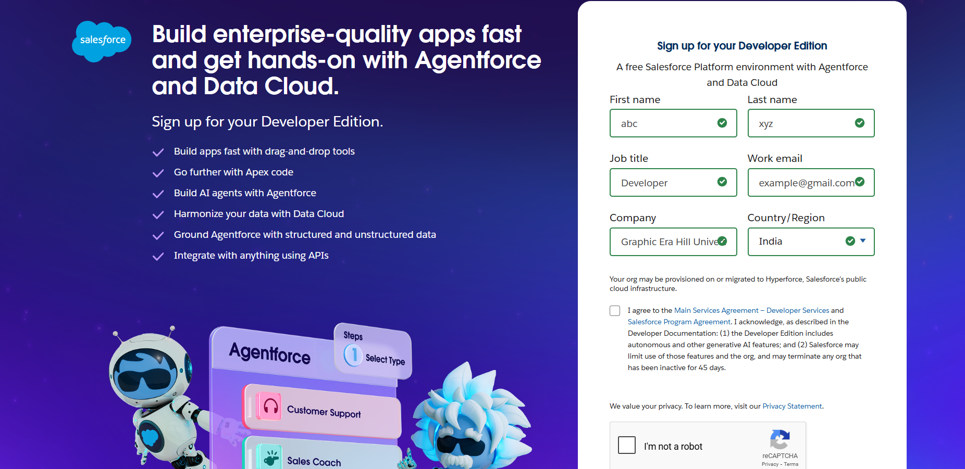

**2. Custom Object Creation**

Five custom objects were created to store business-critical data:

* HandsMen Customer – Stores customer info like email, phone, loyalty status.
* HandsMen Product – Stores product catalog details like SKU, price, and stock.
* HandsMen Order – Stores orders placed by customers, including quantity and status.
* Inventory – Tracks stock quantity and warehouse location.
* Marketing Campaign – Stores promotional campaigns and scheduling.

**Steps followed:**

* Navigated to Setup → Object Manager → Create → Custom Object
* Provided label, name, and enabled reports/search
* Saved and created Tabs for each object

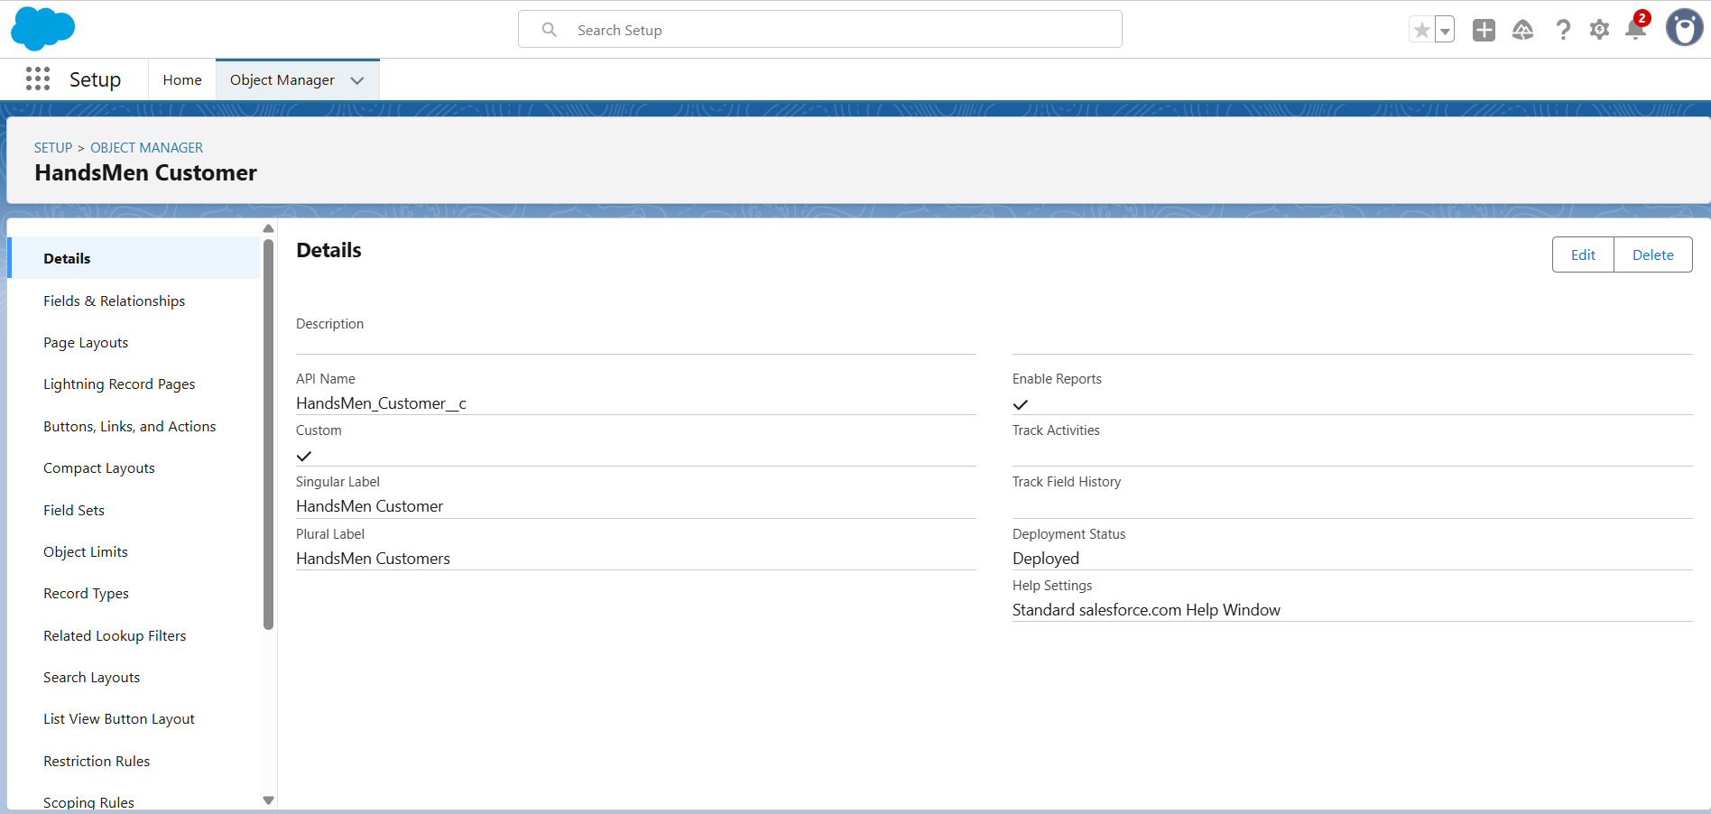

**3. Creating the Lightning App**

* A custom Lightning App named HandsMen Threads was created.
* Included tabs: HandsMen Customer, Order, Product, Inventory, Campaign, Reports, etc.
* Assigned to the System Administrator profile.

**4.** **Validation Rules**

To ensure accurate data entry and enforce business logic, the following validation rules were applied:

* Order Object: Prevents saving if Total_Amount__c <= 0.

Error: “Please Enter Correct Amount”

* Customer Object: Validates email contains @gmail.com.

Error: “Please fill Correct Gmail”

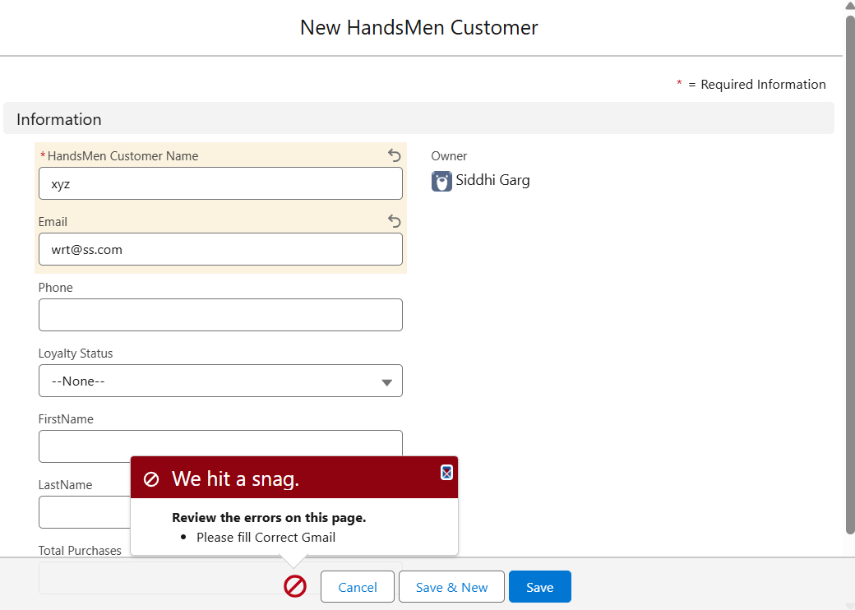

**5.** **User Role & Profile Setup**

* Cloned the Standard User profile to a new profile named Platform 1 and added access to necessary custom objects.
* Created roles for different departments:
* Sales Manager, Inventory Manager, Marketing Team

**6.** **User Creation**

Users were created in Salesforce and assigned appropriate roles and profiles to reflect their responsibilities:

* Niklaus Mikaelson – Assigned the Sales role
* Kol Mikaelson – Assigned the Inventory role
* These role-based assignments help enforce proper data access and process control within the system.

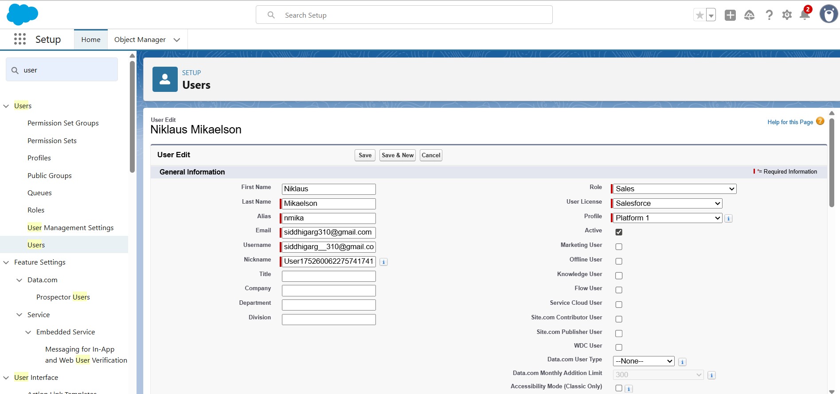

**7.** **Email Template & Alerts**

Created three email templates:

* Order Confirmation – Sent on order status = Confirmed
* Low Stock Alert – Sent when Inventory < 5 units
* Loyalty Program Email – Sent when loyalty status changes

Corresponding Email Alerts were created using these templates and linked to automation flows.

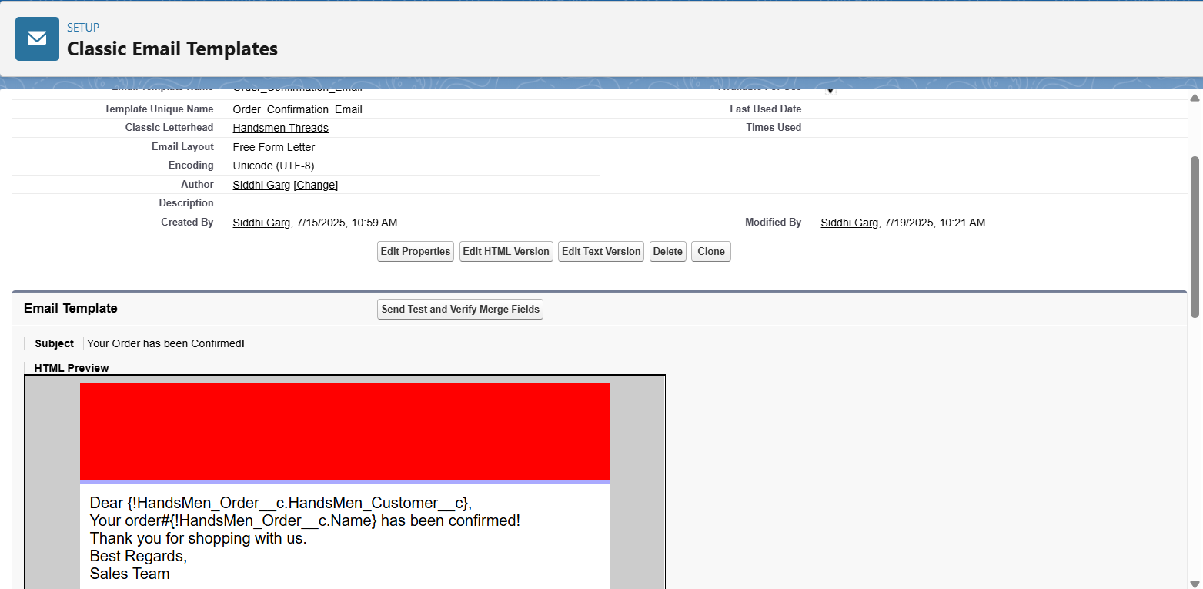

**8.** **Flow Implementations**

**a. Order Confirmation Flow**

Triggered when an order is updated to Confirmed.

Sends an Order Confirmation email to the related customer.

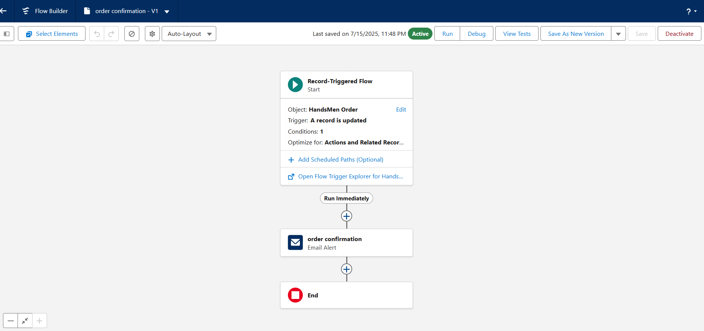

**b. Stock Alert Flow**

Triggered when inventory stock drops below 5.

Sends Low Stock email to Inventory Manager.

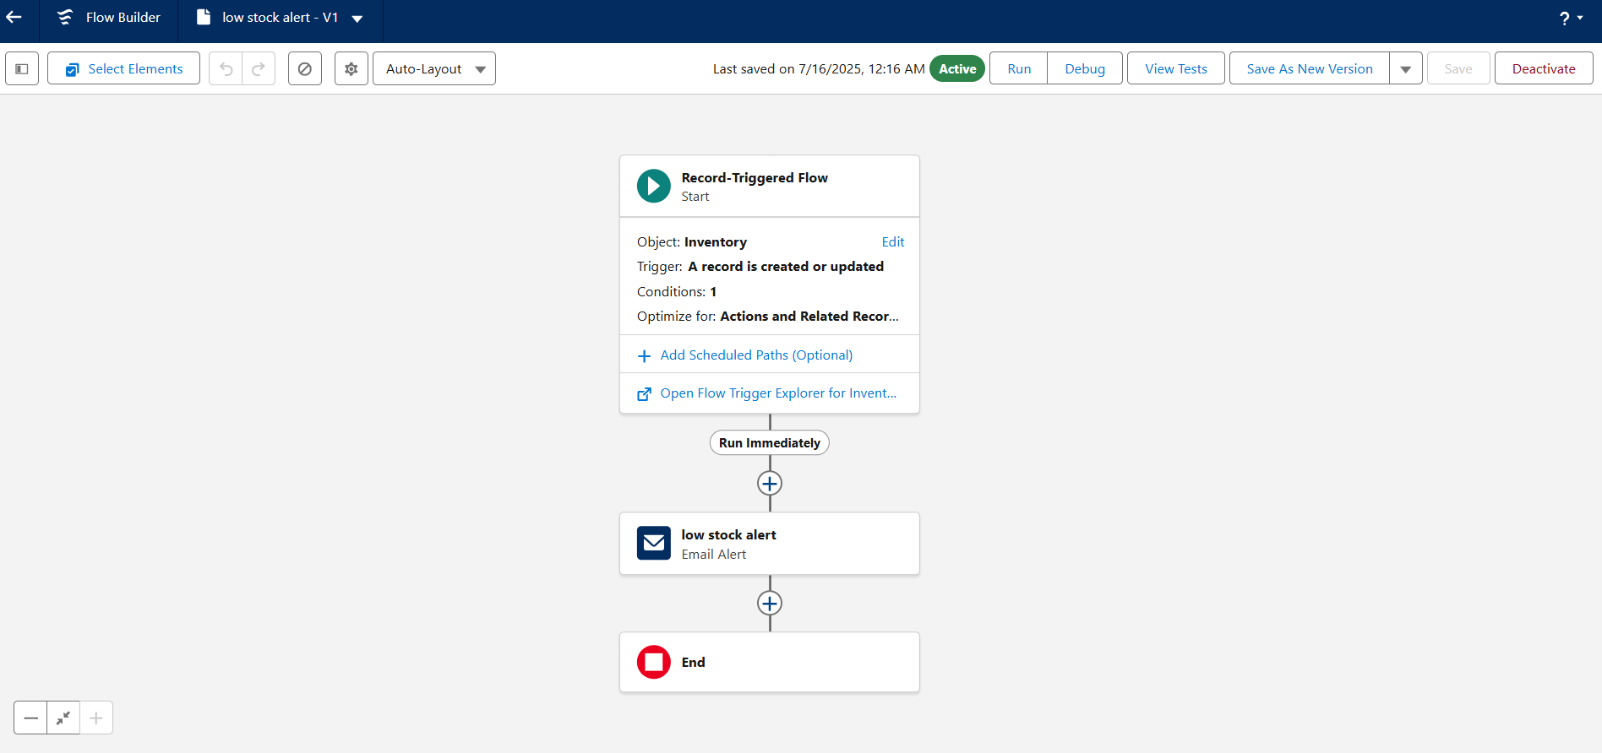

**c. Scheduled Flow: Loyalty Update**

* Runs daily at midnight.
* Loops through customers and updates their Loyalty Status based on total purchases.

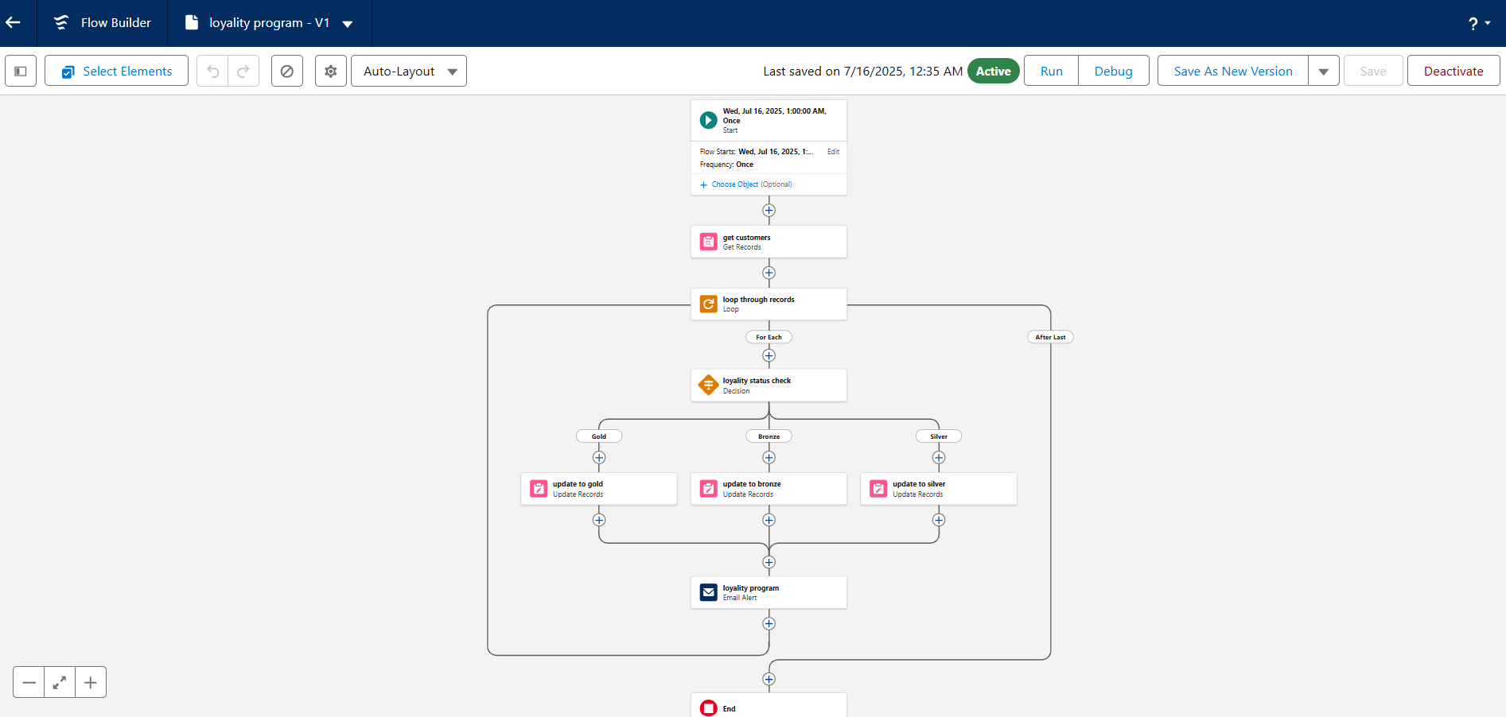

**7. Apex Triggers**

* Order Total Trigger: Auto-calculates Total Amount based on quantity and unit price.
* Stock Deduction Trigger: Reduces stock when an order is placed.
* Loyalty Status Trigger: Updates Loyalty Status based on total purchases.

**PROJECT EXPLANATION WITH REAL-WORLD EXAMPLE**

Let's walk through it like a real customer interaction.

**1. Customer Registration**

A customer, Elijah Mikaelson, visits the store or website.

In Salesforce: A record is created in the Customer object with his name, phone, email, etc.

Validation Rule: Ensures the email is valid (e.g., must contain @gmail.com).

**2. Product Setup**

* The admin adds products like Shirts, Jeans, etc., into the Product_c object.
* Each product has a price and other details.
* Inventory is also created to manage stock for these products.

**3. Order Placement**

* Elijah decides to buy 2 shirts (each 2500). An order is placed.
* In Salesforce: A new Order record is created.
* Apex Trigger: Automatically calculates Total_Amount_c=2×500=1000.

**4. Inventory Update**

* As soon as the order is placed:
* Apex Trigger on Inventory: Reduces shirt stock by 2.
* Validation Rule: Ensures stock never goes below 0.

**5. Loyalty Program**

* Elijah now has a total purchase of ₹1000.
* A trigger on Customer checks his total purchases.

Based on the value:

< ₹500→ Bronze

₹500-1000→ Silver

₹1000 →Gold

* So, Elijah becomes a Silver member.

**6. Email Notifications**

* When a new order is placed or loyalty status is updated:
* Flow + Email Alert is triggered.
* Elijah gets an email:

"Thanks for your purchase! Your loyalty status is now Silver."

**7. Users and Roles**

Salesforce users like store staff are created:

* Niklaus Mikaelson Sales Role (Platform 1 Profile)
* Kol Mikaelson Inventory Role (Platform 1 Profile)

**CONCLUSION**

The HandsMen Threads CRM system built on Salesforce successfully streamlines key business processes like customer management, product cataloging, order processing, inventory tracking, and loyalty program automation. By leveraging Salesforce tools like Custom Objects, Flows, Validation Rules, Email Alerts, and Apex, the system ensures accurate data entry, real-time updates, and enhanced customer experience. Through automation and well-structured user roles, the platform minimizes manual errors, speeds up operations, and provides better insights into sales and stock.